
Grammar helper

сборник грамматических упражнений с интерактивными заданиями для 5-х классов

Белорыбкина Валерия Дмитриевна
Гаврилова Ксения Максимовна
Грязин Демид Владимирович
Пушкина Ксения Александровна
Хоменко Милена Сергеевна
Оглавление
Present Simple 3
Упражнения для отработки Present Simple 4
Интерактивные задания для отработки Present Simple 7
Present Continuous 8
Упражнения для отработки Present Continuous 9
Интерактивные задания для отработки Present Continuous 12
Present Perfect 13
Упражнения для отработки Present Perfect 14
Интерактивные задания для отработки Present Perfect 17
Past Simple 18
Упражнения для отработки Past Simple 19
Интерактивные задания для отработки Past Simple 22
Past Continuous 23
Упражнения для отработки Past Continuous 24
Интерактивное задание для отработки разных временных форм 27
Интерактивные задания для отработки Past Continuous 27

2
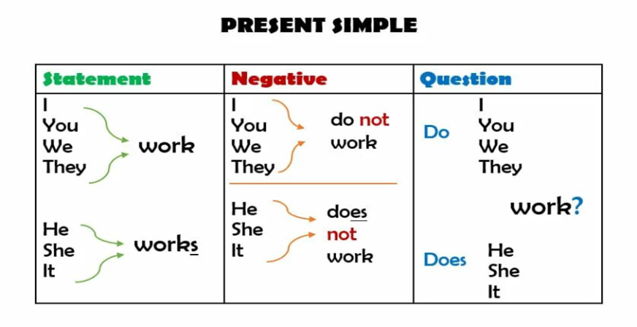

3
Cлучаи употребления Present Simple:
- Описание регулярно повторяющихся действий, например распорядка дня. Пример: «I get up late at the weekend» — «Я встаю поздно на выходных».
- Описание постоянных действий, например рода занятий, хобби, привычек. Пример: «My sister makes and sells slimes online» — «Моя сестра делает и продаёт слаймы по интернету».
- Описание общеизвестных фактов и законов природы. Пример: «The Moon goes round the Earth» — «Луна крутится вокруг Земли».
- Описание расписания самолётов, поездов, фильмов, кораблей и т. д.. Пример: «My plane takes off at 4 pm tomorrow» — «Мой самолёт отправляется завтра в 16:00».
Cлова-маркеры Present Simple: always (всегда), usually (обычно), often (часто), sometimes (иногда), never (никогда), every day/week/month, on Mondays, in the morning.
Present Simple – это настоящее простое время в английском

Present Simple
4
Упражнение 1. Выбери правильный вариант (глагол-связка). Вставь am, is или are.
- I ___ a student.
- My friends ___ kind.
- The cat ___ on the sofa.
- We ___ in the classroom.
- It ___ a sunny day.
- You ___ my best friend.
- His books ___ on the table.
- My mother ___ a teacher.
- They ___ from Spain
Упражнение 2. Раскрой скобки (действия в общем). Поставь глагол в Present Simple.
- My brother often (to play) football.
- I (to like) chocolate ice cream.
- Susan (to study) English every day.
- They (to watch) cartoons on Sundays.
- He (to wash) his face in the morning.
- The bird (to fly) high in the sky.
- We (to do) our homework after school.
- My father (to work) in an office.
- She (to go) to the club on Fridays.
Упражнение 3. Напиши предложения в отрицательной форме. Используй don't или doesn't.
- They live in London.
- He works in a park.
- I understand this rule.
4. We go to school by bus.
5. The dog barks at night.
6. You know the answer.

Упражнения для отработки Present Simple
5
4. We go to school by bus.
5. The dog barks at night.
6. You know the answer.
7. My sister plays the guitar.
8. I want a new phone.
9. Cats like water.
Упражнение 4. Поставь предложения в общий вопрос. Используй Do или Does.
- You speak French.
- He helps his mum.
- They know the answer.
- The lesson starts at 9 o'clock.
- Cats like milk.
- Your parents have a car.
- She finishes work early.
- We need more time.
- It snows in winter here.
Упражнение 5. Ответь на вопросы кратко (Yes, I do. / No, he doesn't).
- Do you like pizza? (+)
- Does your dad drive a car? (+)
- Do they play chess? (-)
- Is your room big? (+)
- Does Anna live here? (-)
- Are you twelve? (+)
- Do monkeys eat bananas? (+)
- Is it cold today? (-)
- Does he play computer games? (-)

6
Упражнение 6. В каждом предложении есть одна ошибка. Найди и исправь её.
- He go to school every day.
- Does she plays the piano?
- My parents doesn't like coffee.
- I am not eat fish.
- She are a good singer.
- We doesn't have a cat.
- Where does he lives?
- They is from Italy.
- Do he swim well?
Упражнение 7. Расположи слова в правильном порядке.
- usually / breakfast / at 8 / have / I
- never / late / is / for school / Tom
- you / do / where / live / ?
- her / does / homework / she / in the evening / ?
- not / my / friend / football / does / play
- sometimes / go / we / to the / cinema
- like / why / you / English / do / ?
- a lot / my / works / sister / of / homework / has
- never / bed / before / goes / to / he / 10 pm
Упражнение 8. Вставь глаголы в скобках в правильной форме.
This is my friend Leo. He ___ (live) in a small town. Leo ___ (get up) at 7 o'clock. He ___ (go) to school. His lessons ___ (start) at 8:30. Leo ___ (like) Maths and Art. After school, he ___ (play) with his friends or ___ (watch) TV. His parents ___ (work) in a shop. They ___ (come) home at 6 pm. In the evening, the family ___ (have) dinner together. Leo ___ (be) a happy boy. His town ___ (be) quiet and nice. Leo's friends also ___ (live) nearby, so they often ___ (meet) after classes. He ___ (not/have) a pet, but he ___ (want) a dog.





7
Соедини случай употребления с примером
Кроссворд
Выбери неверно составленные предложения
Раскрой скобки
Распределение слов-маркеров

Интерактивные задания для отработки Present Simple
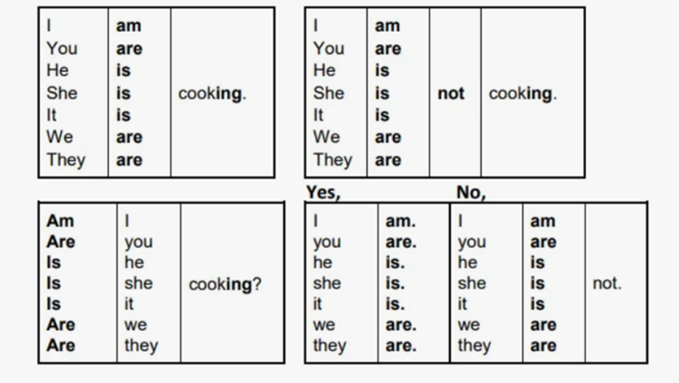

8
Мы используем Present Continuous, когда говорим о действиях, которые происходят прямо сейчас, в момент речи, для выражения будущего действия, описания картинки
В речи часто есть слова-подсказки: now (сейчас), at the moment (в данный момент), Look! (Смотри!), Listen! (Слушай!).
Present Continuous – это настоящее длительное время в английском

Present Continuous
9
1. Напиши глаголы в форме -ing.
1) Play – playing 11) Jump –
2) Swim – 12) Sleep –
3) Run – 13) Work –
4) Draw – 14) Study–
5) Sit – 15) Make –
6) Read – 16) Clean –
7) Watch – 17) Cook –
8) Eat – 18) Dance –
9) Drink – 19) Take –
10) Walk – 20) Come –
2. Раскрой скобки, используя Present Continuous.
- Look! The dog _______________ (run) in the park.
- I _______________ (read) a great book at the moment.
- They _______________ (not/watch) a film, they _______________ (play) a game.
- My brother _______________ (sleep) now.
- She _______________ (wear) a beautiful dress today.
- We _______________ (have) dinner at a new restaurant tonight.
- Why _______________ you _______________ ( cry)?
- Listen! Someone _______________ (knock) at the door.
- The students _______________ (prepare) for an important test this week.

Упражнения для отработки Present Continuous
100
3. Составь предложения из слов. Пример: is / He / TV / watching → He is watching TV.
- am / I / a letter / writing
- are / We / to music / listening
- She / her room / is / cleaning
- They / a cake / are / eating
- He / is / his bike / riding
- Is / It / now / raining
- The cat / on the sofa / sleeping / is
- You / your phone / using / are
- My friends / for the bus / are / waiting
4. Перефразируйте предложения, используя отрицательную форму:
- I'm doing my homework right now. (play games)
- She is reading a book. (watch TV)
- They are swimming in the pool. (play volleyball)
- We are eating dinner. (have breakfast)
- He is riding his bike. (drive a car)
- The cat is sleeping. (run)
- You are listening to music. (read a newspaper)
- My sister is cleaning her room. (draw a picture)
- The students are writing a test. (watch a film)
5. В каждом предложении есть одна ошибка. Найди и исправь её.
- She are watching a cartoon.
- We is eating lunch.
- I am writting a letter.
- They are swiming in the pool.
- He are playing the guitar.
- The cat is sleep on the sofa.
- You am reading a book.
8. My parents is working now.
9. It are raining outside.
11
6. Ответь на вопросы.
- Are you sitting on a chair? – Yes, ___.
- Is it sunny today? – No, ___.
- Are you doing your homework right now? – Yes, ___.
- Are your friends playing football? – No, ___.
- Is your mother cooking dinner? – Yes, ___.
- Are the birds singing? – No, ___.
- Is the teacher explaining a new rule? – Yes, ___.
- Are we having an English lesson? – Yes, ___.
- Are you wearing jeans today? – No, ___.
7. Переведи предложения на английский, используя Present Continuous.
- Моя сестра слушает музыку.
- Я не играю в компьютерные игры сейчас.
- Твои родители работают?
- Смотри! Птицы поют.
- Он не читает, он пишет письмо.
- Почему ты плачешь?
- Мы едим вкусный торт.
- Кот сейчас спит на коврике.
- Я ношу новое платье сегодня.
8. Раскройте скобки, используя Present Simple или Present Continuous:
- She usually (read) books in the evening, but now she (watch) TV.
- They (play) football every Saturday, but today they (visit) their grandparents.
- Look! The children (dance) in the classroom, though they usually (do) exercises at this time.
- I often (drink) coffee in the morning, but right now I (have) tea.
- He (work) in an office from Monday to Friday, but this week he (work) from home.
6. We (go) to the cinema once a month, but tonight we (stay) at home.
7. It often (rain) in autumn, but look, the sun (shine) brightly today.
8. My father usually (cook) dinner on weekends, but today my mother (cook).





12
Распредели глаголы по категориям
Распредели глаголы по категориям
Тест
Раскройте скобки
Что происходит на картинке?

Интерактивные задания для отработки Present Continuous
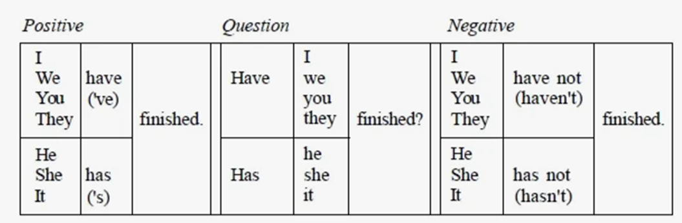

13
Некоторые ситуации, в которых используется Present Perfect:
- Завершенное действие в настоящем. Акцент ставится на результате завершённого действия. I have cooked a good dinner — Я приготовил хороший ужин (действие завершилось, результат — хороший ужин).
- Незавершённое действие в настоящем. Описывается действие, которое началось в прошлом, ещё не закончилось в настоящем, но результат очевиден. Пример: I’ve written five pages of the new book this morning — Я написал пять страниц новой книги этим утром (утро ещё не закончилось, он может написать ещё несколько страниц).
- Опыт или достижения в жизни (когда-либо до настоящего момента). Например: I have visited Japan twice — «Я посетил Японию дважды» (в течение жизни).
Слова-маркеры: already, just, yet, ever, never, lately, recently, this morning, this afternoon, this week, this month, this year, today, since, for.
Present Perfect – это настоящее совершенное время в английском

Present Perfect

14
Упражнение 1. Раскрой скобки, поставив глагол в Present Perfect.
- She (to clean) her room.
- They (to do) their homework.
- He (not / to eat) his sandwich.
- We (not / to see) this cartoon.
- My sister (to lose) her favorite pen.
- You (to break) the pencil.
- I (not / to visit) my grandma this week.
- The lesson (to begin).
- They (not / to feed) the cat yet.
Упражнение 2: «Has или Have?»
- My brother ___ lost his phone.
- I ___ just baked cookies.
- The cat ___ already drunk its milk.
- You ___ got a new friend.
- My parents ___ bought a car.
- This dog ___ never bitten anyone.
- My friends and I ___ finished the project.
- She ___ never been to London.
- They ___ already visited this museum.
- It ___ just started raining.
Упражнение 3. Найди и исправь по одной ошибке в каждом предложении.
- He have never been to London.
- We has just play a computer game.
- She already has drunk her juice.
- I have see this film.
5. They has bought new books.

Упражнения для отработки Present Perfect
15
5. They has bought new books.
6. My sister have just came home.
7. You has never visited this park.
8. We have eated all the cookies.
9. He have already did his exercises.
Упражнение 4. Вставь подходящее слово: just, already или yet.
- Don't wash the cup, I have ___ drunk my tea.
- She has ___ finished her drawing. The paint is still wet!
- Have you done your homework ___? - No, I haven't done it ___.
- Look! He has ___ bought a new bike!
- We have ___ visited this museum, so let's go to another one.
- Have they arrived ___? - Yes, they have ___ come.
- I can't play, I haven't finished my work ___.
- She has ___ told me the news.
- They haven't decided ___ where to go.
- He has ___ solved this difficult problem.
Упражнение 5: «Past Simple или Present Perfect?» Выбери правильное время глагола.
- I (have lost / lost) my key yesterday.
- She (has just finished / just finished) her project.
- They (have bought / bought) a puppy last month.
- We (have never been / never went) to the new museum.
- He (has visited / visited) his grandparents last weekend.
- I (have already done / already did) my homework.
- They (have started / started) learning English two years ago.
- She (has never tried / never tried) sushi in her life.
- We (have just seen / just saw) a wonderful film.
- He (has written / wrote) a letter to his friend last week.

16
Упражнение 6. Переведи предложения, используя Present Perfect.
- Я только что посмотрел интересный фильм.
- Она уже сделала свои уроки?
- Они никогда не летали на самолете.
- Мы ещё не купили подарок на день рождения.
- Он только что пришел домой.
- Ты когда-нибудь видел снег?
- Мы уже прочитали эту книгу.
Упражнение 7. Соедини левую и правую колонку по смыслу.
Действие в Present Perfect Результат в настоящем
1. He has broken the vase. a) Now she can read it.
2. They have gone home. b) Now he is cold and wet.
3. She has received a letter. c) Now it is in pieces on the floor.
4. I have fallen into a puddle. d) Now they aren't here.
Упражнение 8. Задай 3 вопроса однокласснику в Present Perfect, используя слова в скобках.
- (ever / be / another city?)
- (already / have lunch?)
- (read / any interesting book / this year?)
- (ever / meet / a famous person?)
- (already / do / homework for today?)
- (ever / break / something important?)
- (try / any exotic food?)
- (visit / any museums / this month?)
- (ever / forget / your best friend's birthday?)
- (learn / any new English words / this week?)





17
Соедини начало и конец
Заполни пропуски
Раскрой скобки
Найди слова-маркеры
Выбери правильную форму глагола

Интерактивные задания для отработки Present Perfect
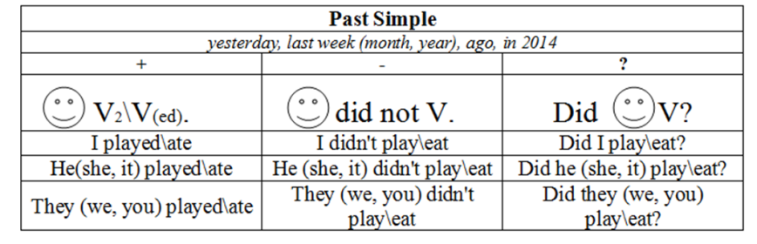


18
Past Simple используется:
- Завершенное действие в прошлом (часто с указанием времени):
I watched a movie yesterday. (Я посмотрел фильм вчера.)
- Последовательность действий в рассказе, пересказ событий:
He came home and had dinner. (Он пришел домой и поужинал)
- Привычные или повторяющиеся действия в прошлом (которые уже не происходят):
When I was a child, I played football every day. (Когда я был ребенком, я играл в футбол каждый день.)
- Факты или общие утверждения о прошлом:
The First World War ended in 1918. (Первая мировая война закончилась в 1918 году.)
Слова – маркеры Past Simple: yesterday (вчера), the day before yesterday (позавчера), last (week/month/year) (на прошлой неделе/в прошлом месяце/в прошлом году), ago (тому назад): two days ago (два дня назад), a long time ago (давным-давно), in 1995, in 2020 (в 1995 году), then (тогда), when I was a child (когда я был ребенком).
Past Simple – простое прошедшее время

Past Simple
19
Упражнение 1. Поставь глагол из скобок в Past Simple, используя вторую форму (не забудь про таблицу неправильных глаголов!).
- I (see) ____ a beautiful bird in the tree.
- He (go) ____ to the cinema last Friday.
- We (have) ____ a big dinner.
- She (write) ____ a letter to her friend.
- They (buy) ____ a new car.
- The movie (to start) _______________ at 8 o'clock sharp.
- My parents (to live) _______________ in this town for many years.
- I (to send) _______________ you an email yesterday, did you get it?
- It (to rain) _______________ heavily all day last Sunday.
- The children (to play) _______________ in the garden all afternoon.
Упражнение 2. Переделайте предложения в отрицательную форму (didn't + V1).
- She enjoyed the party. → _______________
- They understood the instructions. → _______________
- We visited the museum. → _______________
- I knew the answer. → _______________
- She played the piano. → ___________________________
- They worked on Monday. → ___________________________
- We went to the zoo. → ___________________________
- He ate an apple. → ___________________________
- I saw you in the shop. → ___________________________

Упражнения для отработки Past Simple
20
Упражнение 3. Составьте вопросы из данных слов. Все вопросы начинаются с Did.
- (you / see / that accident) → _______________?
- (she / like / the gift) → _______________?
- (they / arrive / on time) → _______________?
- (he / work / yesterday) → _______________?
- (your brother / help / you) → _______________?
- (it / snow / last winter) → _______________?
- (we / meet / before) → _______________?
- (the computer / work) → _______________?
- (your parents / live / abroad) → _______________?
Упражнение 4. В каждом предложении есть одна ошибка в использовании Past Simple. Исправьте ее.
- She didn't went to school yesterday. → _______________.
- Did they played football? → _______________.
- We not see the manager. → _______________.
- Where you did go? → _______________.
- He didn't went to bed early. → ___________________________
- Did she cooked dinner? → ___________________________
- We play chess yesterday. → ___________________________
- My brother studyed for the test. → __________________________
- They didn't saw the monument. → __________________________
Упражнение 5. Заполните пропусками, используя Past Simple.
Last September, I (1) _______________ (start) at a new school. I (2) _______________ (feel) very nervous that morning. My mother (3) _______________ (drive) me there. When I (4) _______________ (arrive), I (5) _______________ (not / know) anyone. A friendly teacher (6) _______________ (meet) me and (7) _______________ (show) me to my class. The students (8) _______________ (be) very nice.
21
Упражнение 6. Напиши о себе. Ответь на вопросы о том, что ты делал(-а) в прошлые выходные. Используй Past Simple.
- What did you do last Saturday morning?
- Did you meet your friends? (Yes/No + подробность)
- What did you watch or read yesterday?
- What time did you go to bed last Sunday?
- Did you enjoy your weekend? Why?
- When were you born?
- What marks did you have yesterday?
Упражнение 7. Раскройте скобки, поставив глаголы в Past Simple.
- I (to meet) _______________ John an hour ago.
- She (to not / to eat) ________ breakfast because she (to be) ________ late.
- What (you / to do) _______________ last weekend?
- They (to build) _______________ this bridge in 1995.
- He (to open) _______ the door and (to see) _______ a stranger.
- We (to not / to have) ____________ any problems with the task.
- The sun (to shine) _______________ brightly yesterday.
- Why (she / to leave) _______________ so early?
- I (to hear) _____ a strange noise and (to go) _________ to check.
Упражнение 8. Выберите правильный вариант: Past Simple vs. Present Simple
- I (see / saw) a great film last night.
- She usually (drinks / drank) tea, but yesterday she (drinks / drank) coffee.
- (Do you go / Did you go) to the party last Friday?
- He (doesn't like / didn't like) vegetables when he (is / was) a child.
- My brother (works / worked) in a bank, but he (quits / quit) last month.
6. (Are you / Were you) at home when I (call / called) you an hour ago?
7. It (rains / rained) every autumn, but it (doesn't rain / didn't rain) yesterday.
8. They (go / went) to the gym every day, but they (don't go / didn't go) there last week.
9. (Does she know / Did she know) about the meeting yesterday?




22
Заполни пропуски
Исправь ошибки в предложениях
Распредели глаголы

Интерактивные задания для отработки Past Simple
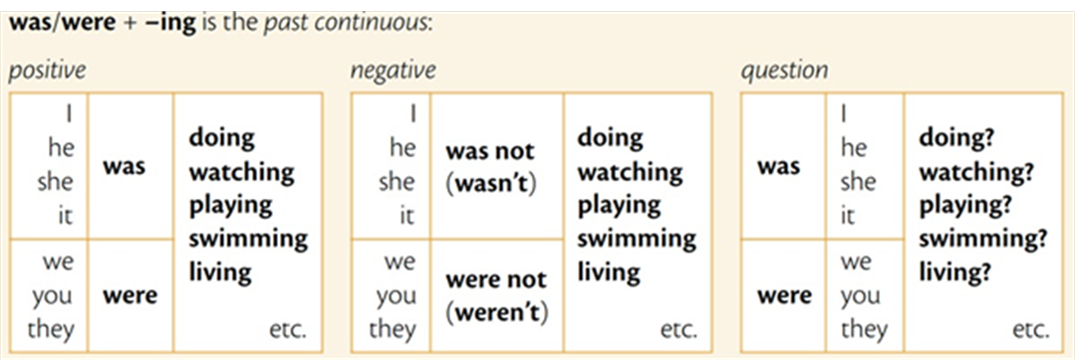


23
- Мы используем Past Continuous, когда говорим о действии, которое длилось в определенный момент времени в прошлом. Мы можем не знать, когда действие началось и закончилось, нам важен сам процесс в прошлом. At 7 p.m. yesterday, I was watching a movie. (Вчера в 7 вечера я смотрел фильм.)
- Когда два длинных действия происходили одновременно в прошлом. While I was cooking dinner, my husband was washing the car. (Пока я готовила ужин, мой муж мыл машину.)
- Когда длительное действие в прошлом (в Past Continuous) было прервано другим, более коротким действием (в Past Simple). Часто используются союзы when (когда) или while (пока). I was walking in the park when it started to rain. (Я гулял в парке, когда начался дождь.)
Слова-маркеры: at 5 p.m. yesterday, at that moment, while (в то время как), when.
Past Continuous – это прошедшее длительное время

Past Continuous
24
Упражнение 1. Напиши глаголы в форме -ing.
- Run - running
- Do
- Take
- Have
- Go
- Say
- Get
- Give
- Put
- Make
- Come
- Know
- Become
- Find
- Think
- See
- Write
- Begin
- Speak
Упражнение 2. Раскрой скобки, используя Past Continuous.
- When the phone rang, I __ (cook) dinner.
- They __ (play) chess at 8 p.m. yesterday.
- He __ (not/listen) to the teacher, he __ (look) out of the window.
- What __ (you/do) when the accident happened?
- At 7 PM yesterday, I __ (watch) a film.
- They __ (play) football when it started to rain.
- She __ (not/sleep) at midnight; she __ (read) a book.
- She __ (train) when I arrived.
9. They __ (play) volleyball all afternoon.

Упражнения для отработки Past Continuous

25
Упражнение 3. Ответь на вопросы полными предложениями.
- Were you sleeping at 11 p.m. last night? – No, ___.
- Was it raining when you left home? – Yes, ___.
- Were your friends waiting for you? – No, ___.
- Were you studying at 8 o’clock yesterday? – Yes, ___.
- Was she cooking dinner when you called? – No, ___.
- Was he playing football in the park? – Yes, ___.
- Was he listening to music in the afternoon? – No, ___.
- Were we walking to school together? – Yes, ___.
- Was the dog barking last night? – No, ___.
- Were you working on the project all day yesterday? – Yes, ___.
Упражнение 4. Переделай предложения, используя отрицательную формулу.
- She was reading a book when I saw her.
- They were swimming in the pool all afternoon.
- You were playing football at that moment.
- I was watching TV last night.
- He was driving to work at 8 a.m.
- We were listening to music during the class.
- The children were sleeping when I came home.
- She was talking on the phone an hour ago.
- They were studying for the exam yesterday evening.
Упражнение 5. В каждом предложении есть одна ошибка. Найди и исправь её.
- She were watching a cartoon the whole evening.
- We were eat lunch when the guests arrived.
- I am writting a letter at that moment.
- They were swiming in the pool.
- You were not sing in the concert.
26
Упражнение 6. Раскройте скобки, используя Past Simple или Past Continuous:
- I (watch) TV when my friend (call).
- She usually (walk) to school, but yesterday her father (drive) her.
- While they (have) a picnic, it (start) to rain.
- We (play) football when it (begin) to snow.
- He (read) a book while she (cook) dinner.
- They (not listen) to music when the teacher (enter) the room.
- I (write) an email when the computer (crash).
- The children (sleep) when the storm (come).
- She (talk) on the phone while her brother (do) homework.
Упражнение 7. Переведи предложения на английский, используя Past Continuous.
- Мой брат смотрел телевизор вчера в 6.
- Я не был в душе, когда ты позвонил.
- Что они делали в то время прошлым вечером?
- Пока она готовила завтрак, дети спали.
Упражнение 8. Составь предложения из слов.
- was / I / a letter / writing
- were / We / to music / listening
- She / her room / was / cleaning
- They / a cake / were / eating
- He / was / his bike / riding




27

Интерактивное задание для отработки разных временных форм
Вставь глаголы
Соедини начало и конец
Опиши картинку

Интерактивные задания для отработки Past Continuous

